PART B & C
1. Explain IPV4 addressing and its address space.
2. Elaborate Subnet mask in detail.
3.
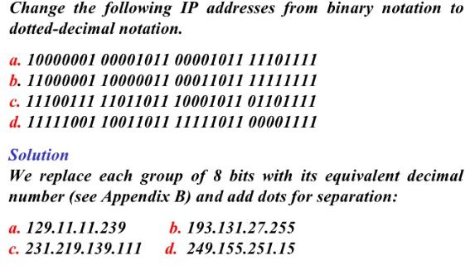
4.
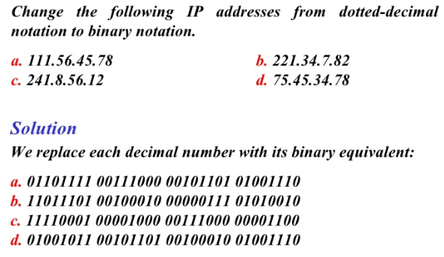
5. Explain addressing modes in IPV4.
6. Describe in detail about Special IP Addresses.
7. Explain with neat diagram about Unicast Addressing,Broadcast Addressing and Mutlicast Addressing.
8. Describe Classless Addressing with example.
9. Explain about the Classful Addressing with example.
10. Explain sub netting with advantages and disadvantages.

11. An organization is granted a block of addresses with the beginning address 14.24.74.0/24. The organization needs to have 3 sub blocks of addresses to use in its three subnets: one sub block of 10 addresses, one sub block of 60 addresses, and one sub block of 120 addresses. Design the sub blocks.

12. Find the Network, broadcast address and host address of the given IP address: 192.168.1.0/27

13. Explain the concept of super netting with its advantages and disadvantages.

14. Describe in detail about NAT(Network Address Translation).

15. Write short notes on Hubs,Routers,Switches and Repeaters.

